1. Which of the following is correct with regard to the oncanplaythrough event fired by media resources in the HTML 5.0 document?
2. The script will run when the media has reached the end.
3. The script will run when the media is played to the end, without stopping for buffering.
4. The script will run when media data is loaded.
5. The script will run when the length of the media is changed.
6. Which of the following is a valid attribute for the <colgroup> element in an HTML 5.0 document?
7. Char
8. Span
9. Align
10. width
11. This question is based upon the figure shown below

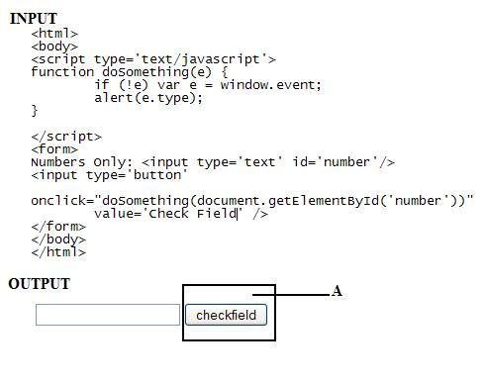

Suppose you add the input code given above to your HTML web page. What result will be returned by the JavaScript function when you click the button marked as A in the image?

1. Number
2. Text
3. Button
4. None of the above
5. The following link is placed on an HTML webpage.<br><br>

&lt;a href="http://msdn.com/" target="_blank"&gt; MSDN &lt;/a&gt;<br><br>

What do you infer from it?

1. It will open the site msdn.com in the same window.
2. It will open the site msdn.com in a new window.
3. It will open the site msdn.com in a frame below.
4. It will not be clickable as it is not formed correctly.
5. Which of the following statements is/are correct for a blockquote?
6. It makes the text a bit bigger for emphasizing.
7. It defines the start of a long quote.
8. It makes the text slightly bolder.
9. Which of the following is NOT an attribute of the <meta> element in HTML 5.0?
10. Charset
11. Content
12. http-equiv
13. scheme
14. In which of the following conditions is a browsing context A allowed to navigate a second browsing context B?
15. When the browsing context A is a nested browsing context and its top-level browsing context is B.
16. When the browsing context B is an auxiliary browsing context and A is allowed to navigate B's opener browsing context.
17. The origin of the active document of A is the same as the origin of the active document of B.
18. All of the above
19. What is the output when you use the HTML 5.0 code snippet shown below?

<body onload="alert(this)">

1. It will alert saying "[object HTMLBodyElement]" when the document is loaded.
2. It will alert saying "[object Window]" when the document is loaded.
3. It will alert saying "[this]" when the document is loaded.
4. The alert message is not properly defined in the body element and an error will be generated when the document is loaded.
5. Which of the following is NOT a supported attribute of the <ol> element in HTML 5.0?
6. Type
7. Reversed
8. Start
9. compact
10. What is the purpose of the <q> element in HTML 5.0?
11. It is used to define the start of a term in a definition list.
12. It is used to define attribute values for one or more columns in a table.
13. It is used to define the start of a short quotation.
14. It is used to define what to show browsers that do not support the ruby element.
15. Which of the following is an INVALID parameter for the window.navigator.registerContentHandler API method in an HTML 5.0 web application?
16. url
17. mimeType
18. scheme
19. title
20. Which of the following is an INVALID value for the type attribute of command tag?
21. Checkbox
22. Radio
23. Command
24. Text
25. Which of the following is NOT a valid syntax for the <link> element in HTML 5.0?
26. <link rel="icon" href="abc.jpg" sizes="16x16">
27. <link rev="stylesheet" href="abc.css" type="text/css" target="_parent">
28. <link rel="alternate" type="application/pdf" hreflang="fr" href="manual-fr">
29. Which event is fired when an element loses its focus in HTML 5.0 document?
30. Onfocus
31. Onload
32. Onblur
33. onselect
34. Which of the following <iframe> attributes are NOT supported in HTML 5.0?
35. Height
36. Marginheight
37. Sandbox
38. scrolling
39. While rendering your HTML 5.0 web page, which of the following <link> element files will get skipped by a compliant user agent if you include the link elements shown below in your document?

<link rel="stylesheet" href="A" type="text/plain">

<link rel="stylesheet" href="B" type="text/css">

1. A link element whose href is "B"
2. A link element whose href is "A"
3. None of the above
4. Which of the following are valid mouse events in HTML 5.0?
5. Ondblclick
6. Ondragstart
7. Ondragenter
8. Onscroll
9. Ondrop
10. How will you change the value of the cookies and items in the Storage objects of the localStorage attributes in HTML 5.0?
11. By invoking the window.dialogArguments() API method.
12. By invoking the window. navigator.yieldForStorageUpdates() API method.
13. By invoking the window.navigator.appName API method.
14. Which of the following <link> attributes are NOT supported in HTML 5.0?
15. Sizes
16. Rev
17. Rel
18. Charset
19. How does a button created by the <button> tag differ from the one created by an <input> tag?
20. An input tag button can be a reset button too.
21. A button tag button can be a reset button too.
22. An input tag button can include images as well.
23. A button tag can include images as well.
24. Which of the following <section> elements have the correct attribute assignment as per HTML 5.0?
25. <section id="example">...</section id="example">
26. <section id="example">...</section id="example2">
27. <section id="EXAMPLE">...</section>
28. <section id="Example">...</section>
29. <section id="example">...</section>
30. Which form event is fired on the click of a button using a button tag with its type attribute value equal to submit?
31. Onload
32. Onsubmit
33. Onunload
34. Onreset
35. How will the target URL open when you define the <a> element in your HTML 5.0 document as shown below
36. The target URL will open in the parent document.
37. The target URL will open in a new window.
38. The target URL will open in the same document in which it was clicked.
39. The target URL will open in the full body of the window.
40. Which of the following is NOT a valid attribute for the <video> element in HTML 5.0?
41. Controls
42. Autoplay
43. Disabled
44. Preload
45. Which of the following is NOT a valid value for the type attribute of the <input> element in HTML 5.0?
46. url
47. week
48. tel
49. radio
50. datetime-local
51. All of the above are the valid values for <input> element
52. Which of the following elements preserves spaces and line breaks, and displays the text in fixed-width font?
53. <xmp>
54. <pre>
55. <p>
56. <q>
57. <br>
58. How will you cancel the timeouts that are set with the setInterval() API method identified by the handlers in HTML 5.0?
59. window.clearInterval (handle)
60. window.clearTimeout (handle)
61. window.setInterval (code, timeout)
62. window.setTimeout (code, timeout)
63. In HTML 5.0, how will the script be executed if you use the script element shown below?

<script src="script.js" type="text/javascript" defer="defer"></script>

1. The script is fetched and executed immediately, before the user agent continues parsing the page.
2. The script will be executed when the page has finished parsing.
3. The script will be executed asynchronously, as soon as it is available.
4. Which of the following are valid values for the contenteditable attribute of the <figure> element in HTML 5.0?
5. True
6. False
7. 0
8. 1
9. Which of the following is the correct method to load another web page or reload the same page in HTML 5.0?
10. <head>

<meta http-equiv=refresh content=5>

</head>

1. <html>

<head>

<title>Auto Reload</title>

<script language="JavaScript">

<!—

var time = null

function move() {

window.location = 'http://site.com'

}

//-->

</script>

</head>

<body onload="timer=setTimeout('move()',5000)">

<p>see this page refresh itself in 5 secs.<p>

</body>

</html>

1. <head>

<meta http-equiv=refresh content="5;URL=http://yahoo.com >

</head>

1. All of the above
2. Which of the following represents INVALID syntax for defining an attribute value in an HTML 5.0 document?
3. <input name ='be evil' />
4. <input name=be evil />
5. <input name = "be-evil" />
6. All of the above.
7. A piece of text contains many blank spaces within it. Which of the following tags would be suitable to display the text as it was originally formatted?
8. Td
9. P
10. Ls
11. pre
12. You specified a base tag and anchors as follows:
13. <base target="_blank">
14. <a href="http://www.yahoo.com">Yahoo</a>
15. <a href="http://www.google.com" target="_top">Google</a>

Which of the following is true of the above code?

1. Only the Yahoo link will open in a new window.
2. Only the Google link will open in a new window.
3. Both links will open in a new window.
4. Both links will open in the same window.
5. A developer wrote this image tag:

<img src ="states.gif" width ="330" height ="406" alt="States"

What code should follow this?

1. <map id ="statemap" name="statemap">

<area shape ="rect" coords ="0,0,82,126" href="state1.htm"

alt="State1" />

</map>

1. Which of the following HTML 5.0 elements is used to embed Java applets into your HTML 5.0 web page?

b. <object>

1. You want to create a link for your website allowing users to email the webmaster. How will you implement this if the webmaster's email address is [webmaster@xcompany.com](mailto:webmaster@xcompany.com)?
2. <a href="mailto:webmaster@xcompany.com">webmaster</a>
3. A computer programming book has to go online. Which of the following tags is ideal for displaying the program snippets?
4. <code>
5. In HTML 5.0, what is the function of the sandbox attribute when used with <iframe> as shown below?
6. It is used to define the restrictions to the frame content.
7. This question is based upon the figure shown below

https://www.expertrating.com/qimages/Knowledge-Of-HTML-Image005.jpg

**Question:**

Which piece of code will you use in your HTML 5.0 document to get the output as shown in the image?

1. <p>My favorite color is <del>blue</del> <ins>red</ins>!</p>
2. What is the purpose of the <keygen> element in HTML 5.0?
3. It is used to generate a public-private key pair in an HTML 5.0 web page.
4. What does the icon attribute of the HTML 5.0 command tag define?

<command icon="?">Click Me!</command>

1. It is used to define the url of an image to display as the command.
2. What is the role of the <dfn> element in HTML 5.0?

d. It is used to define a definition term

1. You are writing the code for an HTML form and you want the browser to retain the form's input values. That is, if a user submits the form and presses the browser's back button, the fully populated form is displayed instead of a blank form. Which of the following HTML 5.0 attributes will you use?
2. autocomplete
3. What will be the result if you use the following code to your HTML 5.0 document?

<bdo dir="rtl">

Here is some text that should be written to your document.

</bdo>

1. .tnemucod ruoy ot nettirw eb dluohs taht txet emos si ereH
2. Which event is fired when the history of the browser window changes?
3. onpopstate
4. In HTML 5.0, which of the following is NOT a valid value for the type attribute when used with the <command> tag shown below?

<command type="?">Click Me!</command>

1. button
2. How will you return a reference to the parent of the current window or subframe in an HTML 5.0 web application?
3. Window.parent
4. Which of the following statements is correct if you allow the user to select only one radio button from a group of radio buttons?
5. The name of the input tag must be the same for all the radio buttons.
6. Which media event is triggered when there is an error in fetching media data in HTML 5.0?
7. onstalled
8. Which of the following languages will you use to paint the graphics designed using the HTML 5.0 <canvas> tag?
9. JavaScript
10. Which of the following tags would assist in creating named groups within a select list?
11. optgroup
12. This question is based upon the figure shown below

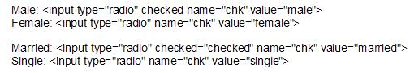

**Question:**

Suppose you placed four radio buttons on a web form. Which of the following statements is correct for the code shown above?

c. The user can choose only one option out of the four.

1. This question is based upon the figure shown below

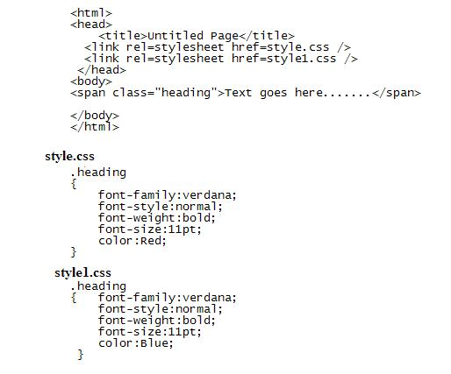

**Question:**

Consider the above code. What will be the impact upon the contents of the element if both the style sheets define the same class?

1. The contents of the element will be of blue color and will inherit all the effects of style1.css.
2. Which of the following events is NOT supported in HTML 5.0?
3. onreset
4. Which of the following is NOT a valid syntax for the <h1> element in HTML 5.0?

b. <h1 align="center"> This is header 1</h1>

1. When is the window onstorage event triggered in the HTML document?
2. It is triggered when the window is resized.
3. It is triggered when a Web Storage area is updated.
4. It is triggered when a document performs an undo function.
5. It is triggered when the window becomes visible.
6. This question is based upon the figure shown below

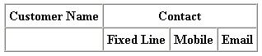

**Question:**

You want to display a table listing out customer names and their contact information. The heading of the table is shown in the given figure. What is the code for creating the first line of the table heading?

b. <tr>

<th>Customer Name</th>

<th colspan=3>Contact</th>

</tr>

1. When does the ondragleave mouse event get fired in HTML 5.0?

b. It gets fired when an element leaves a valid drop target.

1. Which of the following attributes comes in handy when borders have to be put between groups of columns instead of every column?

b. colgroup

1. This question is based upon the figure shown below

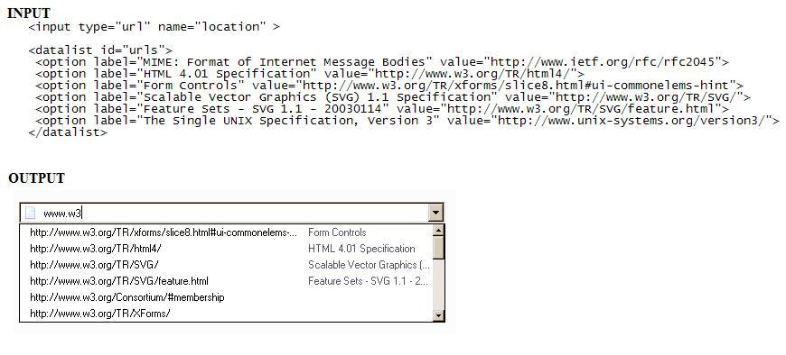

**Question:**

How will you bind the datalist option (shown below) with an <input> element, whose type attribute is set to url, to get the result shown in the image?

1. User should define a list attribute to the input element whose type is url.
2. Which of the following statements is/are correct for a blockquote?
3. It makes the text a bit bigger for emphasizing.
4. It defines the start of a long quote.
5. It makes the text slightly bolder.
6. In HTML 5.0, which of the following attributes of the <object> element refers to the location of the object's data?
7. Type
8. Codebase
9. Data
10. usemap
11. Which HTML 5.0 element will you use to group the related options in a drop-down list?
12. Optgroup
13. Option
14. Menu
15. Var
16. nav
17. What is the function of the history traversal task source in HTML 5.0?
18. It is used for features that react to user interaction, for example, keyboard or mouse input.
19. It is used for features that react to DOM manipulations, for example, the things that happen asynchronously when an element is inserted in the document.
20. It is used to queue calls to history.back() and similar APIs.
21. All of the above.
22. Which <iframe> attribute is used to define the restrictions to the frame content in HTML 5.0?

b. sandbox

1. What is the default background color for the canvas element in HTML 5.0?
2. Black
3. White
4. Transparent
5. Gray
6. Which of the following statements are correct with regard to <hr> and <br> elements of HTML 5.0?
7. <hr> element acts in the same way as the Tab key on your keyboard and <br> element acts in the same way as the SHIFT key on your keyboard.
8. <hr> element is used to insert the horizontal line within your document and <br> element is used to insert a single line break.
9. <hr> element is used to put a line across the page and <br> element acts in the same way as the ENTER key on your keyboard.
10. Which media event will be fired when a media resource element suddenly becomes empty?
11. Onerror
12. Onended
13. Onloadeddata
14. Onemptied
15. Consider the following items of a <select> list:

<option value="89">Item 1</option>

<option value="90">Item 2</option>

Which of the following values would be passed on by clicking the submit button on selecting Item 2 from the list?

1. 89
2. 90
3. Item 1
4. Item 2
5. Which of the following statements is correct if you invoke the window.prompt (message, default) web application API method in HTML 5.0?
6. It will only show the modal text field prompt with the given message to the user.
7. It will show the modal text field prompt with the given message to the user, and ask the user to respond with a positive or negative response.
8. It will show the modal text field prompt with the given message to the user, and ask the user to either respond with a string value or abort.
9. Both b and c.
10. What will be the return value when using the window.navigator.appName API method in an HTML 5.0 web application?
11. It will return the version of the browser.
12. It will return the complete User-Agent header.
13. It will return the name of the platform.
14. It will return the name of the browser.